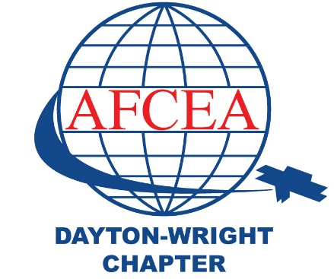Dayton Wright AFCEA Chapter - AMMO Case Study

# Fallen Warrior Memorial Park Summary:

The Fallen Warrior Park is a memorial park dedicated to honoring local heroes who have fallen in battle.

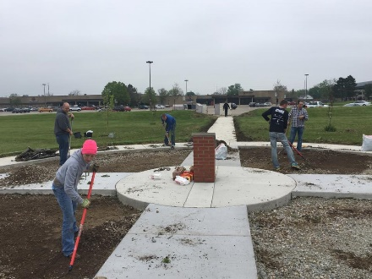This Outreach project was led by multiple organizations and numerous volunteers. The primary leadership and volunteer force were organized by the Dayton- Wright Young AFCEANs, Wright Patt Junior Force Council and Leadership Wright Patt.

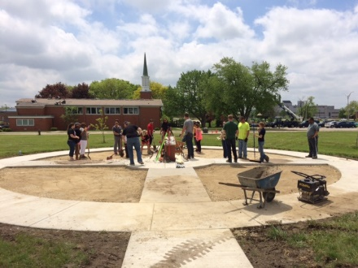The land and the identification of the park podium took place in 2011. The first phase and ground-breaking event in Nov. 2014 was when the Chapter and many volunteers planted the initial 13 trees. In the Spring of 2014, volunteers completed phase 2; which included concrete pathways, lighting, benches, pavers, and a ribbon cutting ceremony to officially open the park. Many people were involved but I’d like to take a moment to thank those initial leaders who drove this project to completion: Danna Plewe, Brent Ahlers, Christian Ryan, Amanda Thompson, PJ Falter, Caroline Hawkins, Gabriel Rivera and Claire Revalee. These individual’s leadership and determination helped us raise the necessary funds and make the Fallen Warrior Park a reality.